The nuanced picture this survey shows has not changed much in the past year. It still portrays loyal faculty who are extremely concerned about what is going on in the institution and with their personal future after they have lost a significant portion of their salary and benefits in recent years. The picture though is not only of financial distress but also of personal distress where employees feel abandoned and undervalued by the university. It also seems that faculty have marginal confidence in the leadership of the university and in this leadership moving the university forward.

The survey this year was taken by fewer YU faculty – maybe there was less interest given that last year’s survey did not seem to have much of an impact.
In fact, about 2/3 of the respondents (61.6%) said that the situation this year is not much different than last year, and this is reflected in the survey. The summary below compares this year’s results to last year’s results.

Faculty perception of how the university views them

This part of the survey seems to show a slight improvement.

On average 73.7% (2018: 69.6%) of faculty agreed (said they either “somewhat agreed”, “agreed” or “strongly agreed”) with the statement that they like coming to work at YU. This somewhat higher percentage than last year is consistent with the higher percentage 33.5% (compared to 2018: 24.3%) who said that they “Have not considered a job in another institution”. Still, 2/3 of the respondents did consider a job in another institution this year as well.

Another slight improvement over last year, is that 51.5% (2018: 46%; “somewhat agreed” and higher) agree that they feel they are valued as employees however, only 50% (2018:53.9%) feel that their professional contributions are valued by the university.
This year, 41.8% (2018: 36.5%) agreed (“somewhat agreed” and higher) with the notion that YU cares about them as people and only 41.8% (2018: 33.9%) think that YU is treating them in a fair manner. Finally, only 41.2% (2018: 35.7%) said they would recommend YU to their friends and colleagues as a working place. While there is some improvement in some parameters this year, still most faculty do not feel that YU cares, and most faculty would not recommend YU to colleagues, which makes recruiting difficult.

Faculty’s recommendation for a course of action-

Here we see small changes compared to last year

Faculty were asked about the plan of action the university should take in the immediate future.
The most common answer was to increase pension plan contributions (47.1% vs 45.5%) while a the second most popular answer (30.7 vs 37%) was to create a plan for faculty raises and compensation.

Faculty was asked what course of action the faculty council should take to try and resolve some of the issues the faculty is concerned about. 25.3% (2018: 21.7%) suggested expressing privately the concerns to the provost and the president, while 30.5% (2018: 30.4%) suggested expressing concerns publicly but limiting it to the confines of the university (such as students, faculty and employees). 17.4% (2018:19.1%) wanted to find some public mechanism of non-cooperation with the administration. Only 2.1% (2018: 4.3%) suggested to take no action at this time and to give the administration additional time to act on their own.

Faculty’s confidence in YU leadership
Unfortunately, it seems that the continuing difficult situation is coupled with an additional erosion in the confidence in the leadership. The only slight improvement was with regards the board of trustees.
We asked about the level of confidence faculty had in its leaders. 37.7% (2018: 40%) agreed (either “somewhat agreed”, “agreed” or “strongly agreed”) with the statement “I have confidence in President Berman”. 26.2% (2018: 31.3%) agreed (either “somewhat agreed”, “agreed” or “strongly agreed”) with the statement “I have confidence in Provost Botman”. We looked into the statement “I have confidence that the Provost office is transparent and provides all information to faculty” and found that 22.4% (2018: 16.1%) agreed with that statement.
Here are the confidence numbers for the Deans (the first number is this year, the second last year): Sy Syms (76.9% vs 88.2%), YC (38.7% vs. 53%), SCW/STERN (70% vs. 64%), Cardozo (81.3% vs. 87%), Ferkauf (33.3% 71.4%) , Wurzweiller (83.3%) .
In general, there is a decline in the support for the Deans too, but only at YC and Frekauf most faculty do not support the Dean.
Finally we looked at the confidence in the board of trustees and found that only 27.3% (2018: 21.7%) agreed with the statement (either “somewhat agreed”, “agreed” or “strongly agreed”) “I have confidence in the Board of Trustees”. Only 17.5% (2018: 12.2%) agreed with “I have confidence in the “university’s expertise in financial management”.

Appendix
Demographics: N=195; gender: Female=39.3%, male = 45.5%; income: 70.2% $160k<; age: 60% <55 years old; type of faculty: 70.2% are full time faculty

New question – 61.6% said the university stayed more or less the same as last year.

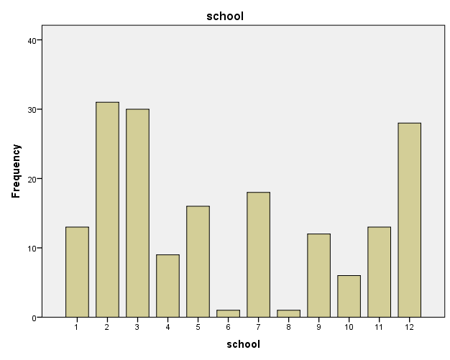

1=sy syms; 2=YC, 3= SCW/Stern; 4= Katz; 5=Cardozo, 6= Revel; 7=Ferkauf; 8=Azrieli; 9=Wurzweiller; 10=Reits; 11=other; 12=prefer not to answer

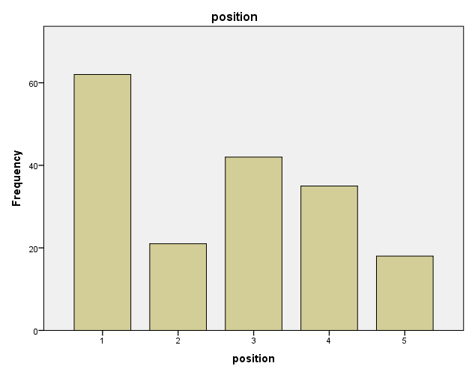

1=Tenured faculty; 2= Tenure track faculty; 3=Full time non tenure track faculty; 4= Part-time (adjunct); 5=other

We reported schools that had at least 10 faculty participating in the survey

